Mill Creek Academy
“Field of Pink”
Breast Cancer Awareness
Find the Cure!
Purchase A Flag!

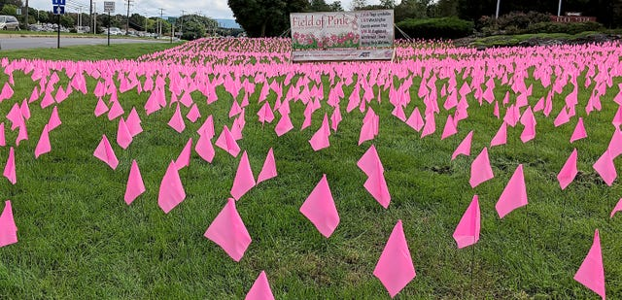
Mill Creek Academy National Junior Honor Society is supporting Breast Cancer Awareness month by selling pink flags to create a “Field of Pink” in front of the school. We are selling pink flags for $1.00 each. You can write a brief message or someone’s name on the pink flag that you purchase to adorn the school’s front lawn for a week in October. We will sell flags from September 13th to October 11th. Thank you!
Name/Contributor: _____________________________________________________________
# of flags: ________________________ x $1.00 each = ________________

Message to be written on the flag(s).
Message/Name for each flag (optional): ____________________________________________________________________________________________________________________________________________________________
Message/Name for each flag (optional): ____________________________________________________________________________________________________________________________________________________________
Message/Name for each flag (Optional): ____________________________________________________________________________________________________________________________________________________________

Please return to Laura Tollefson’s mailbox or bring to room 625 in the Middle School building.

