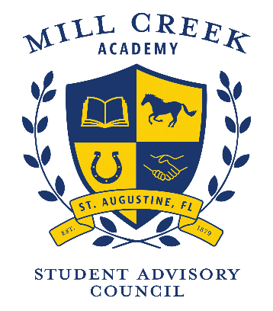

Meeting Agenda
Meeting Location: via Skype
Thank you for volunteering to serve Mill Creek Academy. We value your time, opinions and dedication.
TIME | AGENDA ITEM | FACILITATOR
3:30 | Welcome | Arthur Thomas  Christi Thomas
3:35 | Approval of September minutes | Christi Thomas
3:40 | District Focus Group Scheduled for October 28, 2020 at 3:00PM. Would someone like to attend and report back to the SAC with any updates. | Christi Thomas
3:45 | ELA Textbook Adoption Committee Opportunity  During the fall of 2020, St. Johns County Schools will be participating in the process of textbook adoption for English Language Arts. We are in need of non-instructional members (i.e., parents, community members) for the textbook adoption committee. Committee members will have the opportunity to review a variety of ELA instructional resources and provide valuable feedback. This process will be completed in mid-December, all meetings will be virtual, and every effort will be made to minimize your time commitment. If you are interested in being considered for this opportunity, please give your name (and email address) to your SAC chair. | Arthur Thomas
3:50 | Budget Update | Arthur Thomas
3:55 | Funds Request – Flocabulary 3rd Grade - $1040.30 | Lindsay Hodges
4:00 | Funds Request – Additional Fundations - $2014.20 | Denise Shely
4:05 | Celebrations- Homecoming Week  Red Ribbon Week  Safety Matters  SBDL Students progress monitoring - RTI | Amanda Riedl
4:30 | Reminder: Agenda Suggestions Email Christi or Arthur by Friday, 11/19  Adjourn | Arthur Thomas

Next meeting: November 24, 2020

