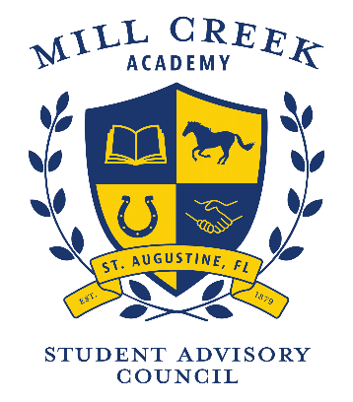

Mill Creek Academy
Meeting Agenda

Thank you for volunteering to serve Mill Creek Academy. We value your time, opinions and dedication. We look forward to a wonderful year
TIME | AGENDA ITEM | FACILITATOR
4:00 | Welcome  Review and approval of January minutes | Dawn Wilkey  Art Thomas
4:05 | Budget Update – No funds request this month | Art Thomas
4:10 | Survey completion numbers to date | Art Thomas
4:20 | SAC Survey Closing Dates - Proposed March 17, 2021 | Art Thomas
4:25 | Celebrations | Ken Goodwin
5:00 | Adjourn | Dawn Wilkey  Art Thomas

Next meeting: Tuesday, March 30, 2021

