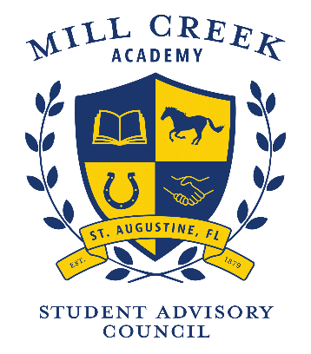

Mill Creek Academy
Meeting Agenda

Thank you for volunteering to serve Mill Creek Academy. We value your time, opinions and dedication. We look forward to a wonderful year
TIME | AGENDA ITEM | FACILITATOR
4:00 | Welcome | Arthur Thomas  Dawn Wilkey
4:05 | Review and approval of February minutes | Arthur Thomas  Dawn Wilkey
4:10 | Budget Update | Art Thomas
4:15 | Funds Request – Gradecam | Leah Willis
4:20 | Funds Request – Fundations | Courtney Warner
4:25 | Code of Conduct Input Survey | Dawn Wilkey
4:30 | District Focus Group Update | Stephanie Sanalila
4:40 | Questions about end of year celebrations/trips | SAC Discussion
4:45 | MCA Updates | Ken Goodwin
4:50 | School Recognition Funds Voting Procedures – Update for SAC | Arthur Thomas  Dawn Wilkey
5:00 | Adjourn | Arthur Thomas  Dawn Wilkey

Next meeting: April 27, 2021

