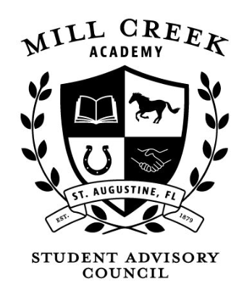

Mill Creek Academy SAC
Meeting Schedule
2021-2022

All meetings will be held from 4:00pm-5:00pm in classroom 211.

If for any reason you are unable to attend a meeting, please email Christi Thomas (Christi.Thomas@stjohns.k12.fl.us ) or Art Thomas (Arthur.Thomas@stjohns.k12.fl.us ). Thank you.

Tuesday September 28th, 2021 – 4:00PM
Tuesday October 26th, 2021 – 4:00PM
Tuesday November 30th, 2021 – 4:00PM
December – No Meeting
Tuesday January 25th, 2022 – 4:00PM
Tuesday February 22nd, 2022 – 4:00PM
Tuesday March 29th, 2022 – 4:00PM
Tuesday April 26th, 2022 – 4:00PM
Tuesday May 31st, 2022 – 4:00PM

