Mill Creek’s Summer Reading Challenge 2021

All students entering Kindergarten through 5th grade at Mill Creek have the opportunity to participate in our Summer Reading Challenge by coloring in each box and completing a full BINGO card. Additional cards can be found on the Mill Creek website. Once completed, you must have a parent/guardian sign the bottom verifying that you have completed each box as indicated.
Prizes
* A completed BINGO card will receive a free sno-cone
** A completed BINGO card and a second card will receive a sno-cone and will be entered into a drawing to win $10.00 in books! We will draw one winner per grade!

Parents and Caregivers,
As we gallop into the summer months, you will be looking for ways to engage your students in learning that is fun! Below are links to some additional resources beyond our summer challenges you found in your student’s report card. This page is also available on the MCA website where you can click on the links for access.
A calendar that gives easy family reading ideas for each day of the week.

http://www.fldoe.org/academics/standards/just-read-fl/families/summer-activities-elementary.stml
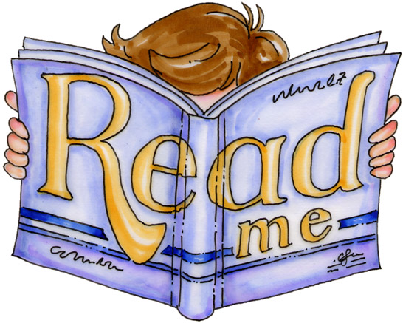

Starfall
http://www.starfall.com/

Helping Your Child Become a Reader
http://www.fldoe.org/academics/standards/just-read-fl/families/helping-your-child-become-a-reader.stml

Storylineonline
A read aloud website by the Screen Actors Guild in which authentic literature
is read aloud and brought to life.
http://www.storylineonline.net

Time for Kids
The latest news, brain games, and homework help are just a few of the things you'll find at this kid-friendly site. http://www.timeforkids.com/

Read Write Think
http://www.readwritethink.org/parent-afterschool-resources/

K-2 students will have continued access to RAZ-Kids throughout the summer. Continue to use the log in information that you have used all year for this great online reading resource. Did you know that RAZ-Kids books are also available on Android and iOS devices? Go to www.raz-kids.com/mobile for details.

St Johns County Public Library has a plethora of wonderful resources for summer fun Don’t forget you can also visit the library all summer long to check out books. https://sjcpls.overdrive.com/
Speaking of libraries and checking out books…this link will take you to the American Library Association’s suggested summer reading lists. They are in an easy to print format that you can take with you to your local library.
http://www.ala.org/alsc/2015-summer-reading-list

Create  a  character  trading card | Read a book recommended by a friend | Read at the beach  or pool | Read  while riding  in the car | Read in the dark with a flashlight
Read to  Someone  younger than you | Create a  bookmark | Read under  a tree or in the park | Read while  having a  picnic | Read aloud in a funny  voice
Read to a friend | Read the 2nd  book in a series | Read somewhere in  your house | Read at the  library | Read wearing sunglasses
Read to a pet or  Stuffed animal | Read a non – fiction book | Read in  another city,  state or country | Read at a  bookstore | Read standing  up
Read to someone  over the phone | Read  a graphic  Novel | Read under the  stars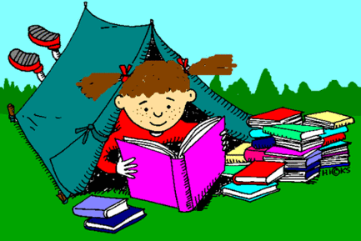 | Read while in your room | Create a  crossword  puzzle
Mill Creek’s Summer Reading Challenge 2021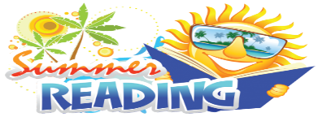

Mill Creek Academy
Future 6th to 8th graders
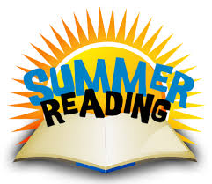
Reading Challenge 2021
This summer’s challenge for our upcoming 6th graders to 8th graders is to read a minimum of 2 novels and sell their favorite book next year by presenting it in their Language Arts class in a unique and creative way! Some examples that may be used: (PowerPoint, advertisement, portray a character from the book, or an essay)
- Students that read a minimum of 2 novels and present one of them will receive a sno-cone

- The student that reads the most novels will receive a Barnes and Nobel gift card

This form must be turned in by : August 20, 2021 with the activity to the 6^{th,} 7th or 8th Grade ELA Teacher
ELA TEACHERS will return this form to Ms. Crystal Kelly, ILC by 8/27/21
My son/daughter has read a minimum of 2 novels
Book Titles/Authors: __________________________________________________________________________________
___________________________________________________________________________________
_____Yes, my son/daughter has read a minimum of 2 novels
Parent Signature______________________________________________________________________
ELA Teacher Signature _________________________________________________________________

